
Year 8 Science 2015

Geology Topic Test – 10%

  - Name ____________________________
  - Teacher ____________________________
  - Score _____ / 32 _____ %

Section 1 – Multiple Choice
 | A sample of obsidian has no visible crystals because it:  - is not an igneous rock.  - was not made from crystalline substances.  - cooled too quickly when it was formed.  - was formed by volcanic eruption, under temperatures too high to allow crystals to form. | C | 1
 | You have found a piece of rock that contains three different coloured crystals: black, white and grey. The crystals in this rock are large. This rock sample is most likely to:  - be granite.  - be extrusive granite.  - have cooled quickly.  - be obsidian. | A | 1
 | Erosion is the:  - breaking up of rocks.  - formation of good soil.  - removal of vegetation by people.  - movement of soil and rock from one place to another. | D | 1
 | A rock formed below the surface of the Earth is called:  - intrusive.  - extrusive.  - obtrusive.  - a monolith. | A | 1
 | The process by which rocks are broken down into smaller rocks by natural events is called:  - weather-beaten.  - weathering.  - erosion.  - decomposition. | B | 1
 | Erosion is best described as the:  - breakdown of rocky material.  - cementing together of small rock particles.  - movement of weathered materials from one place to another.  - formation of soil. | C | 1
 | Basalt is an example of which type of rock?  - Sedimentary  - Metamorphic  - Igneous  - Artificial | C | 1
 | Rocks transformed from one type of rock into another by heat or large amounts of pressure are called:  - igneous.  - metamorphic.  - volcanic.  - sedentary. | B | 1
 | Which of these rocks is NOT a metamorphic rock?  - Quartzite  - Slate  - Granite  - Marble | C | 1
 | The following diagram shows a number of layers of sedimentary rock.    The oldest layer of rock in the diagram would most likely be:  - layer A.  - layer B.  - layer E.  - layer C. | C | 1
 | Which of the following rock types is an example of a metamorphic rock?  - Granite  - Sandstone  - Limestone  - Marble | D | 1
 | Rocks that form from volcanic lava flows are classified as:  - igneous rocks.  - metamorphic rocks.  - sedimentary rocks.  - conglomerate rocks. | A | 1

Section 2 – Short Answer
 | Rocks such as pumice have many holes in them. How are these holes formed? | They are formed by gases that are trapped in molten lava as it cools. | 2
 | Why do rocks formed underground generally have larger crystals than rocks formed above the ground? | Rocks formed beneath the ground take longer to cool. This allows larger crystals to grow. | 2
 | Describe two causes of weathering. | Answers will vary but may include wind and acid rain. | 2
 | What is soil composed of? | Weathered rock and decayed plant and animal material | 2
 | Name two sedimentary rocks that have been formed from the remains of living things, and give a use for each. | Answers will vary. Examples include: limestone, used in mortar; coal, used as a fuel. | 2
 | Give two factors that affect the formation of metamorphic rocks. | Answers will vary but may include: type of rock, amount of heat, amount of pressure and rate of change. | 2
 | Draw diagrams that explain the difference between conglomerate rock and sandstone. (Hint: Think about the grains in each type of rock.) | 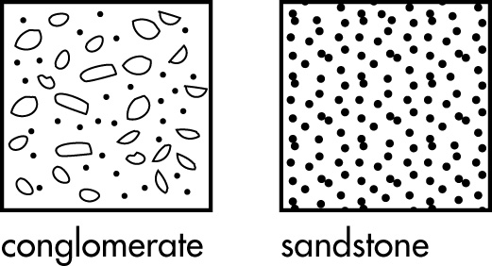 | 2
 | Which of these rocks are formed mainly by heating while under pressure?  (Circle all that apply.)  Quartzite  Slate  Granite  Marble  All of the above | Quartzite and Marble | 2
 | What is the main difference between intrusive and extrusive rocks? | Intrusive rocks are formed below ground; extrusive rocks are formed above ground. | 2
 | Which two of the following are common igneous rocks? (Circle two).  Pumice  Quartz  Basalt  Sandstone | Pumice and Basalt | 2

